**GANGNAM STYLE LYRICS**

**https://24x7offshoring.com/**

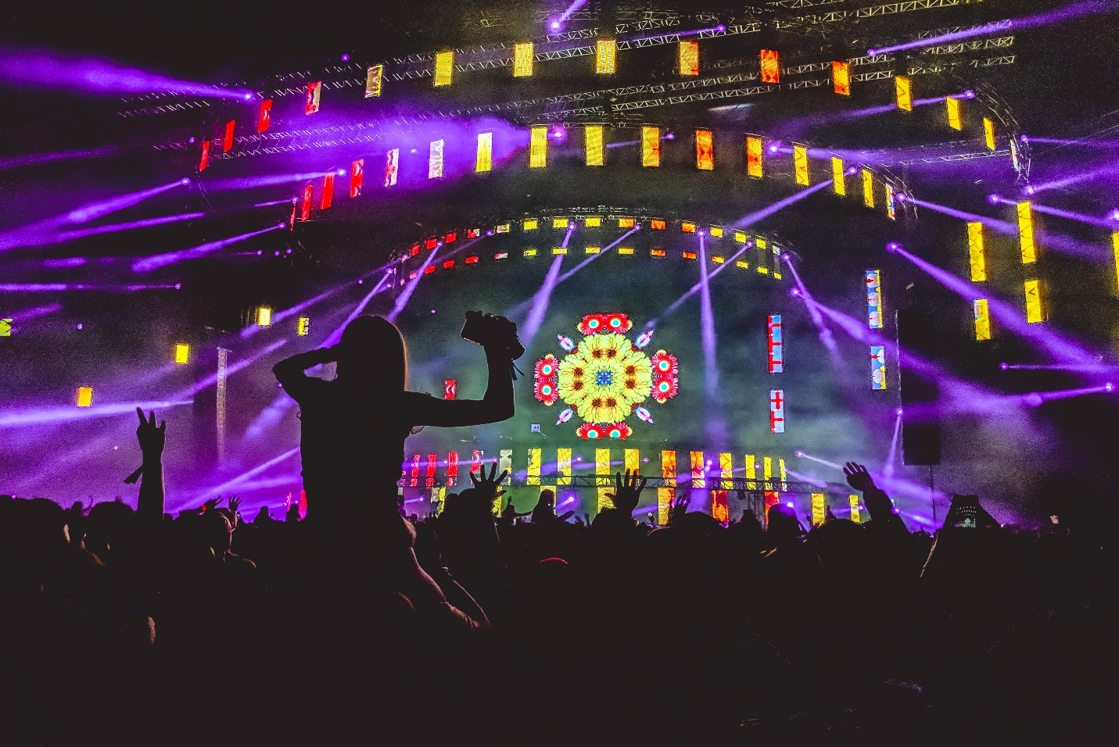[**http://24x7outsourcing.com/**](http://24x7outsourcing.com/)

**Korean to English Translation of Gangnam Style Lyrics**

**The K-Pop Invasion**

South Korean K-pop artist Psy is the main Korean artist/entertainer to beat out everyone else in the U.S., however all over Europe and the UK. Psy's acclaimed music video Gangnam Style, which turned into a web sensation on You-Tube in August of 2012, has arrived at above and beyond 1 billion perspectives - a record-breaking accomplishment by a long shot.

Gangnam Style is a record-breaker from various perspectives:

It is the main Korean language tune to get famous in the U.S and the UK; the primary K-pop melody and craftsman to become showbiz royalty outside of Korea, and the principal video to outperform the measure of perspectives recently held by Justin Bieber, on You-Tube.

**Imaginative Korean Translation Needed for Oppa Gangnam Style**

While there are numerous offerances of Korean to English interpretation out there for Gangnam Style verses, crowds don't mind if they comprehend the verses.

Through music, moving and visual humor, the level at which Gangnam Style strikes a quick preference for every one of the individuals who see and hear it, is one that can outperform the boundary of unknown dialect:

Which is something both astounding and infrequently found, without a doubt, particularly on account of the inclination for standard music crowds in America to learn and chime in to their number one music.

For guardians in almost any piece of the world, on the off chance that you have kids under 30, odds are they've seen the Gangnam Style music video on You-Tube - presumably more than once.

Psy's diverting but gifted moving, his silly video substance, and his ascerbic hits at the richest group of friends in South Korea are largely reasons why Psy's music and his music video are a particularly hit, that the tune has since a long time ago saturated numerous parts of American culture, and become a long ways past the music video itself.

There is even film of President Obama doing the celebrated Gangnam Style horse-dance Psy made for the tune. (It's not really President Obama, yet an entertainer dressed like him. Notwithstanding, he has confessed to moving "Gangnam Style" to humiliate his girls).

No, it isn't prompt concern whether we comprehend Psy's Korean rap, or in the event that we even truly know what "Gangnam Style" is, for sure "Oppan Gangnam Style" signifies.

We love the tune if we get it.

In any case, because of its hazardous overall prevalence, the characteristic movement of interest and interest has driven us to a huge number of fan requests, a meeting by the New York Times, and many websites, articles and Q&A's about Psy and Gangnam Style: Everyone needs to know what "Oppan Gangnam Style" signifies. Thus, that question has additionally been addressed many, ordinarily.

The exacting interpretation is "More seasoned Brother has Gangnam Style."

So, for what reason are on the whole the English interpretations of the melody's verses "Oppa has Gangnam Style" as opposed to "Older sibling?"

Since Korean to English interpretation for a tune like Gangnam Style is once in a while best left in Korean:

"Oppa" is a Korean familial (easygoing) term for a more seasoned sibling by a more youthful sister, or for any marginally more established male by a more youthful female.

**GANGNAM STYLE LYRICS**

**https://24x7offshoring.com/**

**http://24x7outsourcing.com/**